KANWIL

1. 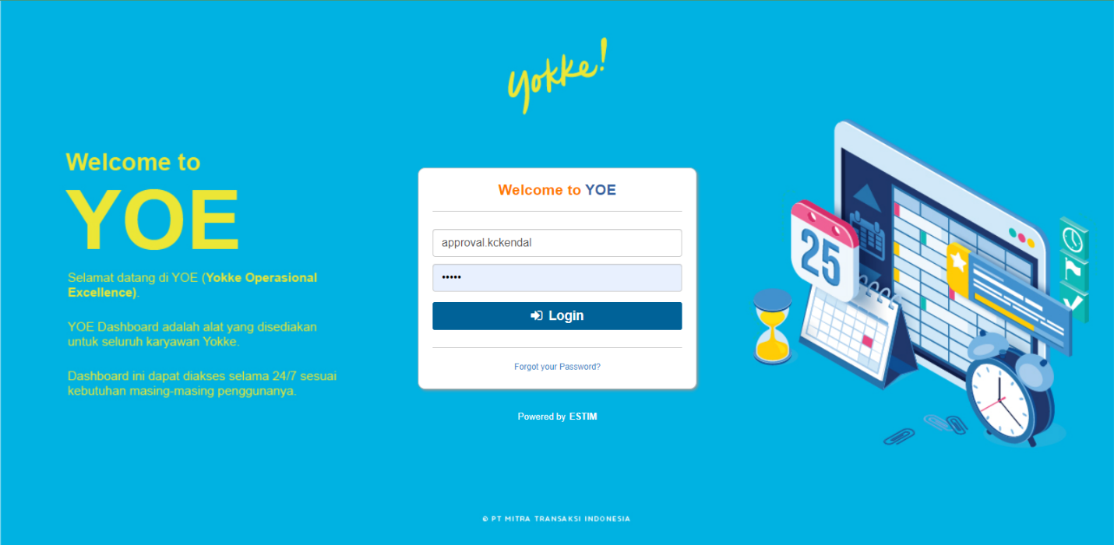login di web yoe dan melakukan Assignment Group
2. A screenshot of a computer

   Description automatically generatedKlik menu Merchant Registration -> Member Bank Approval -> pilih tiket dan klik edit
3. 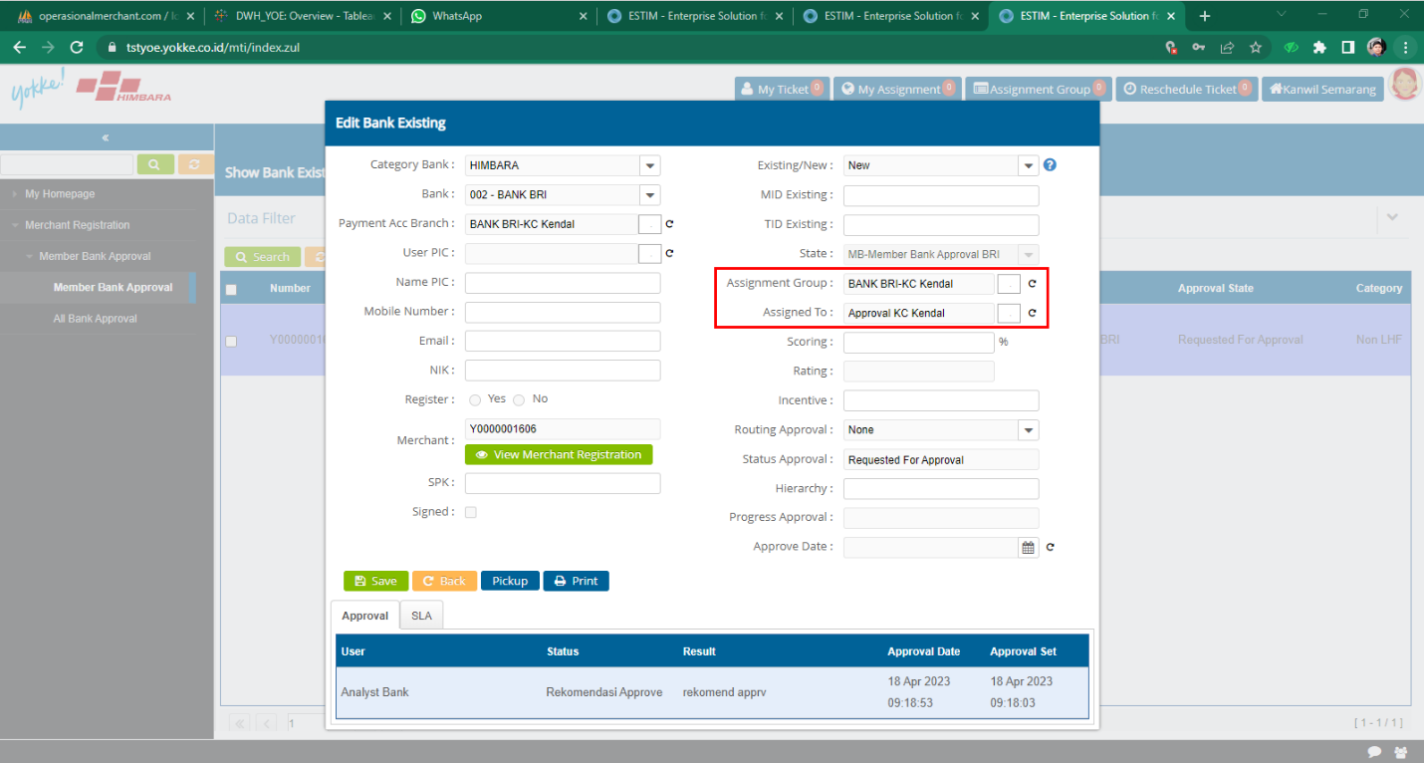Pilih Assigned Group dan Assigned to sesuai dengan kc yang akan di pilih lalu klik save
4. Graphical user interface, application

   Description automatically generatedSetelah di save lalu klik back

APPROVAL KC TERPILIH

1. A screenshot of a computer

   Description automatically generatedA picture containing graphical user interface

   Description automatically generatedLogin Sebagain Approval KC Lalu klik Merchant Registration -> Member Bank Approval -> pilih tiket dan klik edit
2. Graphical user interface, application

   Description automatically generatedKlik pickup -> yes -> klik action
3. isi Assigned To sesuai admin KC

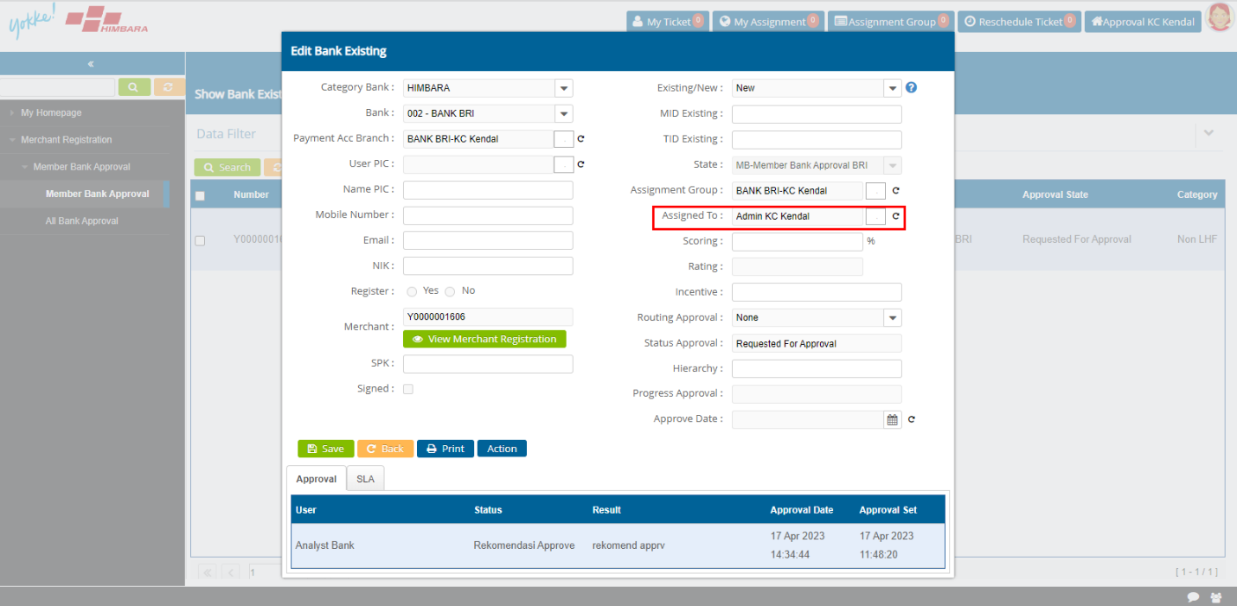

1. 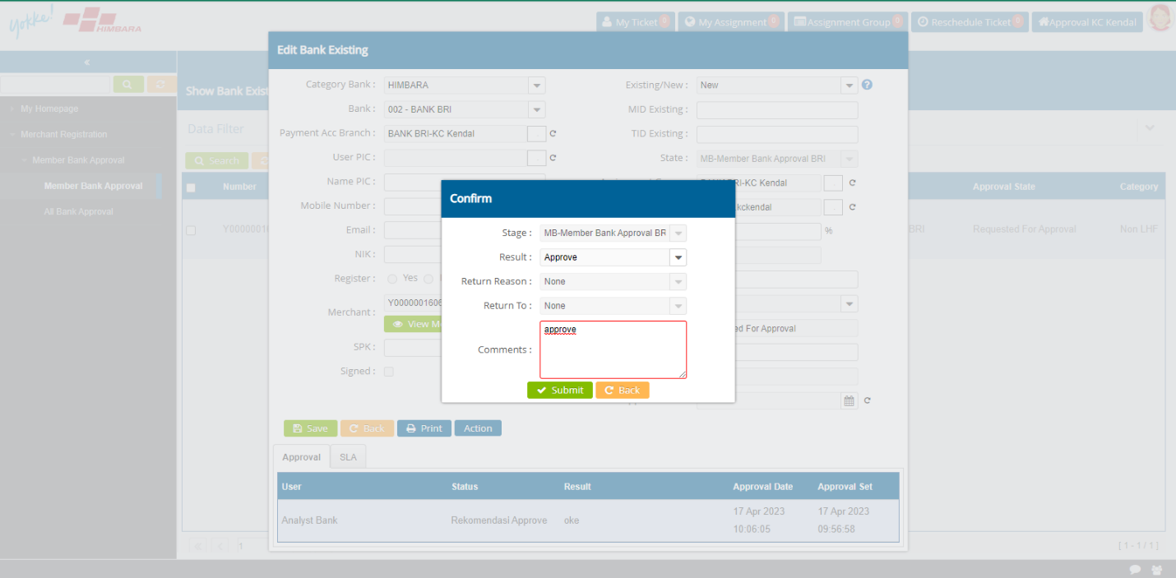Pilih approve / reject, lalu submit
2. isi Assigned To sesuai admin KC, lalu save

ADMIN CABANG

1. Melakukan Pickup tiket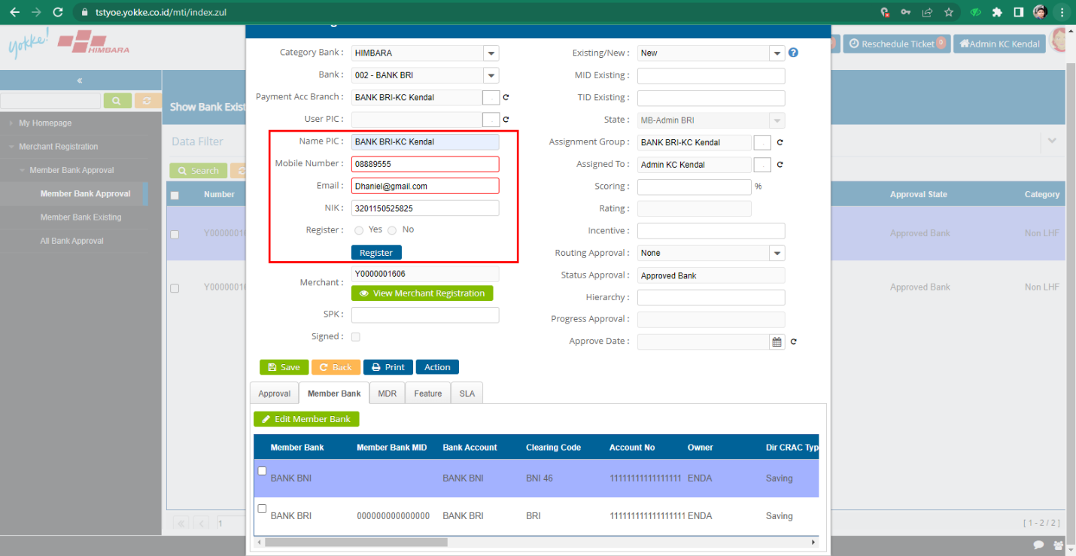, lalu Isi form untuk pic memberbank, jika sudah di isi klik register
2. 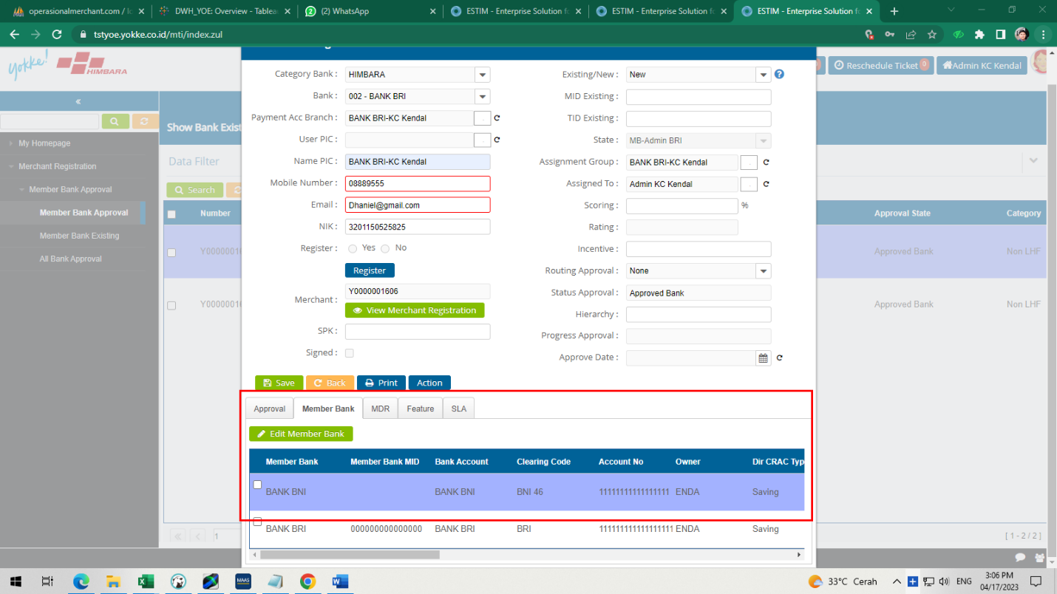klik edit memberbank untuk mengisi MID member bank lalu save

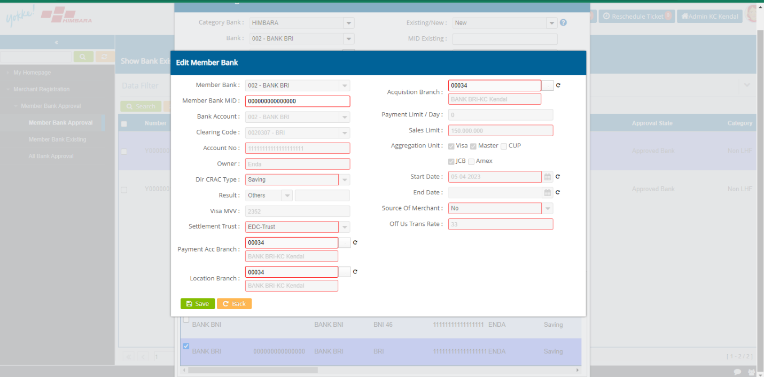

1. klik edit EDC Feature untuk mengisi TID member bank lalu save

1. Action tiket , lalu submit

